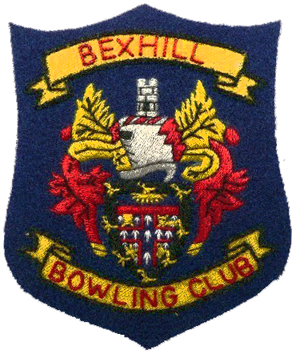

Bexhill Bowling Club
founded 1907
Affiliated to Bowls England, Sussex County Bowls and Sussex County Women’s Bowls

Bexhill Bowling Club offers a warm welcome to all new members.

Application for Membership
John Bishop
Secretary
Bexhill Bowling Club
Please complete and return via e-mail to: - bexhillbowlingclub.secretary@gmail.com
Tel. No: - 01424 846196
Date: - …………………………
(Full Name in block Capitals) …………………………………………………………………...
wish to apply for Membership of Bexhill Bowling Club.
If elected, I agree, to abide by the rules and bye laws of the Club.

*I am a new bowler / I was previously / I am already / a Member of

………………………………………………………………………………… Bowling Club
.
my handicap was / is……………………. in the handicap range ………………. (Delete as applicable)
Address: -
……………………………………………………..

……………………………………………………..

……………………………………………………..

Post Code ………………………………………..

Tel no ……………………………………………..

Proposed by ………………………………………………

Seconded by …………………………………………… (Both being members of Bexhill Bowling Club)

