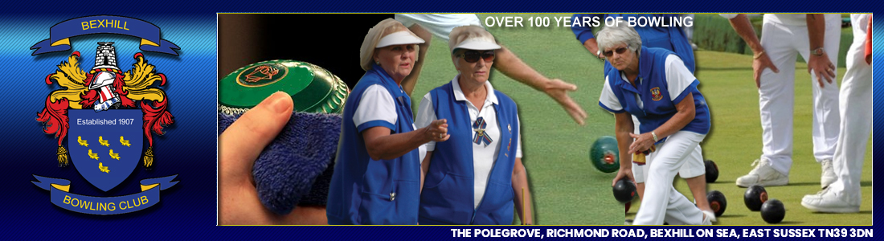
Bexhill Bowling Club
The Marker’s Duties January 2021
Taken from World Bowls Laws of the Sport of Bowls - The marker’s duties
1. In the absence of an umpire, the marker should make sure that all aspects of play are carried out in line with the Laws of the Sport of Bowls.
2. Centre the jack.
3. Mark all touchers with chalk. Players should allow the marker to chalk mark touchers before playing their next wood.
4. Place dead bowls on the bank.
5. Place red or white markers in the ditch to show resting position(s) of a live jack and any live bowls.
6. Using the stick spot the jack 2 metres from the front ditch if it is delivered within that distance.
7. Wear grey trousers and white shirt. All whites in a final. The committee will not vigorously enforce this rule, especially during earlier rounds when we understand some matches may take place at short notice.
8. Carry chalk or spray-chalk and a measure. Also before the start of each game the Marker should ensure all the equipment is available- 2 mats, a jack, two sticks, two pushers, a scoreboard and red and white blocks (1 each colour each end) for showing where bowls and/or jack in the ditch is. The players should help collecting these items before and after the game.
9. Give your constant attention to the head, players, and adjacent rinks.
10. Do not engage the players in conversation.
11. Only talk with the players if they initiate it. The only player allowed to ask questions is the player that has possession of the mat.
12. Markers should make sure the jack is at least 23 metres from the front mat line after it has been centred.
13. NEVER block a bowler’s vision of a rink marker.
14. Stand to one side of the rink, behind the jack and away from the head.
15. Do not allow yourself to be distracted from the game you are marking.
16. DO NOT walk towards the head to look it over unless a player requests information.
17. When a player asks if he is holding shot, unless it is obvious it is best to signal “it’s a measure”. Giving wrong information could be disastrous.
18. In general, do not volunteer information, but when a player asks a question, do not make them continue ask related questions. “You’re up two” is better than “You’re up.”
19. STOP an incoming bowl or any other neutral object from an adjacent rink if it is likely to disturb the head on your rink.
20. When a runner is delivered, move to the front of the head where you will be in a much better position to observe the action and avoid moving objects.
21. Do not stop or catch bowls which are about to enter the ditch.
22. If both players ask you to measure, have them remove all bowls not in contention.
23. If the players asked you to keep score, wait until they mutually agree on the end before recording it.
24. If you are at the end with the scoreboard keep it up to date.
25. Ensure both players sign the scorecard and place it in the correct box for the attention of the competition committee.
THANKS FOR MARKING
Without your generous and knowledgeable service, Singles would be very tiresome

